Introduction to Economics (Summer Task) Battle of the Economists

Deadline: bring to first economics lesson in September
Your Task: Over the next 2 years you will be studying a wealth of theories that make up economics. These theories have been developed by a number of famous Economists. Your task is to investigate the work of TWO economists.
You can either produce you work as a poster or a report (handwritten, word limit 1000 words). Use the following guidelines to help you structure and complete the task. You can choose any TWO from the following list:
Robert Solow
Elinor Ostrom
Jacob Viner
John Nash
Arthur Laffer
David Ricardo

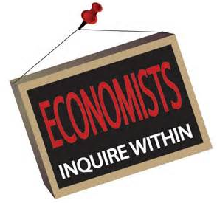
Adam Smith
John Maynard Keynes
Milton Friedman
Friedrich Hayek
George Akerlof
Alfred Marshall

For EACH economist research and report on:
Their Background:
For example: When they lived, where they lived, what they looked like (picture or photo) university/education, job/career (you can use Wikipedia research for this section ONLY)

Their main economic theory that changed economics:
- What is their theory called?
- When we it published?
- Explain (using your own words) how their theory works

What impact did their theory have on the real world?
How did their theory change the way people, businesses, economies function? i.e.
What are the benefits/positive outcomes of their theory? What are the criticisms/problems/limitations with their theory?

Now for the difficult bit:

Compare your 2 Economists: Who would win in a battle of the Economists?
Answer this by making a judgement and explain your choice with the help of these questions:
Whose theory had a bigger impact on the world of Economics? Explain why you think this? Why did you think the other economist’s theory had a lessor impact on the world of Economics?

