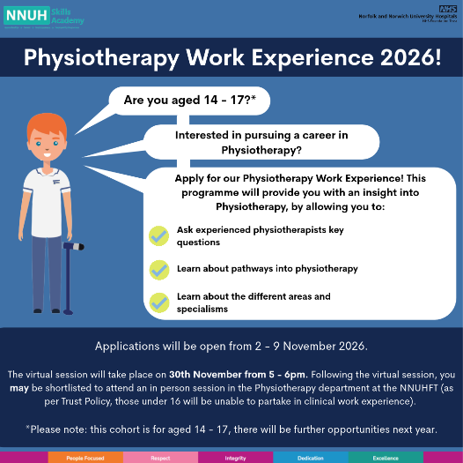

Apply through the Skills Academy webpage:
www.nnuh.nhs.uk/training-education/nnuh-skills-academy/work-experience/

or the Skills Academy social media pages (click logos to follow links):



